 **BSc (Hons) in Information Technology**

**Software Engineering – Year 3**

**Lab sheet 06**

**SE3050 – User Experience engineering Semester 2, 2021**

Sketching

Wireframes

IT19114590

IT19176802

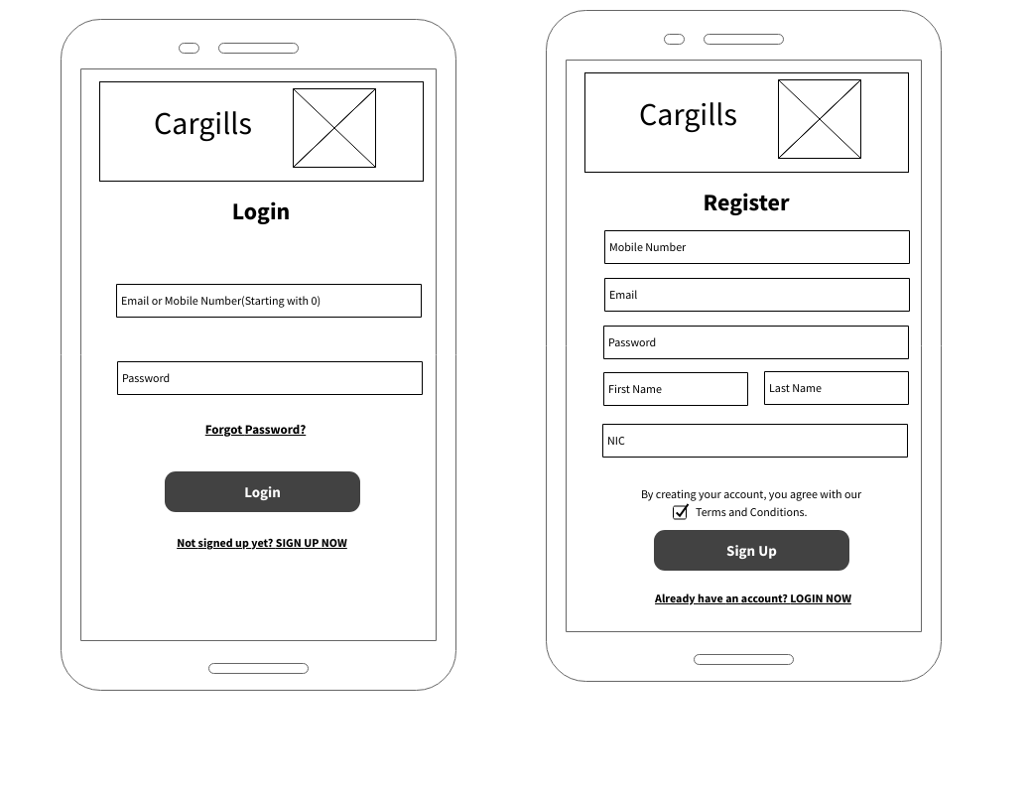

Prototype (Low-fidelity or high-fidelity)

Version 1

IT19114590

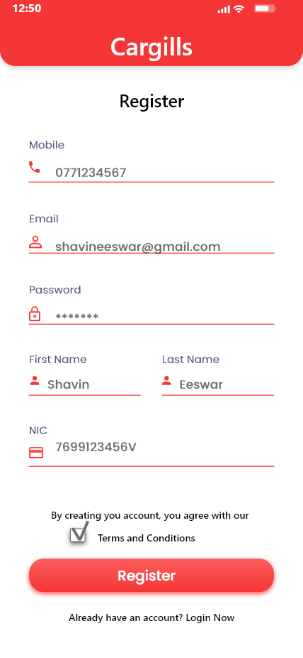

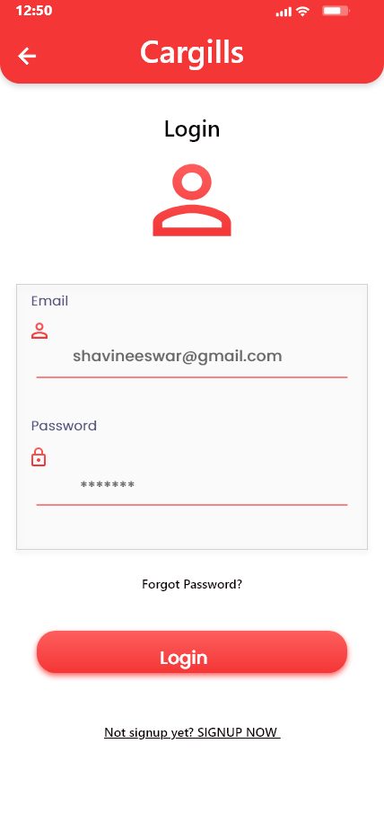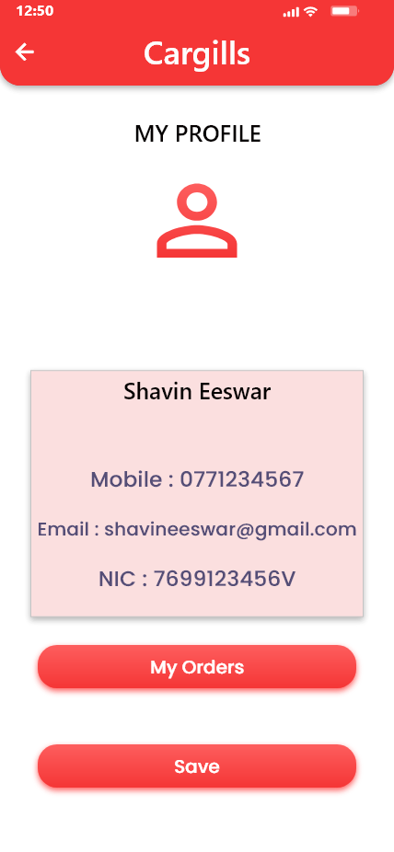

Interview Script

Hello < interviewer name >, In the last interview we collected your feedback and opinions about the Cargills app. As per your information we have design sketches and we have come up with some wireframes and prototype of UI with some solutions.

Today we are here to get the feedback on the UI designs which have designed. Also, we except

your positive and negative comments about design UIs which would be make the app more efficient

and user friendly.

We believe that user feeling, and the suggestion are most important thing, So whatever you say to us is important to us, so we’d like to take notes.

To make sure our notes correctly represent what you say, we would also like to take a

video/sound recording. Of course, the recording is confidential and will not be shared around.

If you have no objections, we’ll proceed with the questions?

Common Question

Hope after the last interview you have visited to Cargills app several time. While that time did you find anything should be improve which u didn't mention in last interview?

**Login, Registration and User profile**

1. Did you find anything to improve from the Login and Register page?

2. As you preferred, we have added NIC in profile also we have designed to edit the phone number. Is there anything to improve?

**Delivery Address & my orders interface**

1. How would you describe your experience navigating through the delivery function?

2. As you suggested during the previous interview, we have added the map view and the scheduling delivery processes to improve usability. Is there anything else you’d like to add or change in those interfaces?

**Home page, Category page, Product page and Search page**

1. Do you think the app design and functions of the home, category, product, or Search page match its purpose?

2. Does anything seem out of place or unnecessary in the Home, category, product, or Search page?

**Shopping cart and payment process**

1.How do you feel throughout place the order function's interface? Is that ok or need some improvements?

2.Were there any features missing from card details insertion interface that you expected?

Ending interview

That's the end of the questions.

I am grateful for interviewing with you today.

May I contact you if we have any other questions or for possible further research for this project?

Thank you for your valuable contribution. It was helpful.

**Version 2**

IT19114590

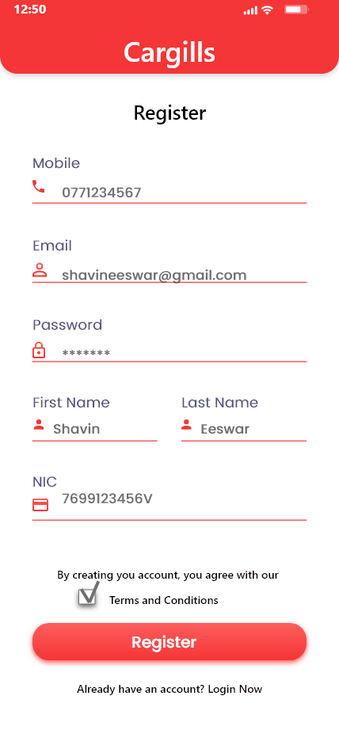

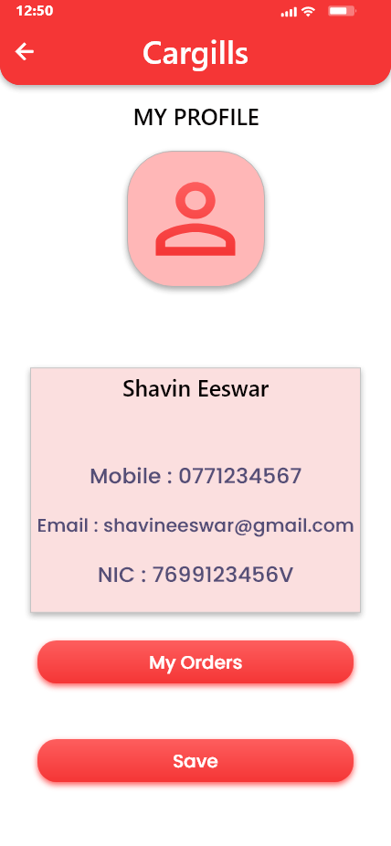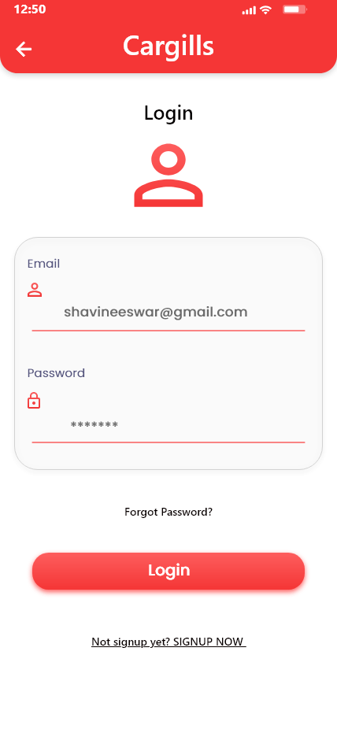

Contribution

|  |  |  |  |
| --- | --- | --- | --- |
| **Group ID** | **Student Reg. No** | **Student Name** | **Contribution** |
| 2021S2_REG_WD_08 | IT19244044 | J.S.Samaratunga | Delivery Address & my orders interface |
| IT19114590 | G.Nivethika | Home page, Category page, Product page and Search page |
| IT19051376 | W.W.M.Anjana | Shopping cart and payment process |
| IT19176802 | S.S.Eeswar | Login, Registration and User profile |